Report on

**THE MUSICAL WEBSITE**

*Submitted in partial fulfillment for the award of the degree*

*Of*

THIRD YEAR OF ENGINEERING

*In*

COMPUTER ENGINEERING

By

Tanya Talwar

***Under the Guidance of***

*Mrs****.*** Veena Kulkarni

Designation



**University of Mumbai**

**Department of Computer Engineering (2016-17)**



[**TEG**](http://www.thakureducation.org/)

**CERTIFICATE**

This is to certify that Ms. Tanya Talwar, are bonafide students of Thakur College of Engineering and Technology, Mumbai. They have satisfactorily completed the requirements of the MINIPROJECT as prescribed by University of Mumbai while working on “MiniProject Title”.

|  |  |  |
| --- | --- | --- |
| **Ms./Mr./Dr. ……………**  **(Guide)** |  | **Dr. Rekha Sharma  ( HOD CMPN)** |

**Internal Examiner: External Examiner:**

**Signature with Date:…………….. Signature with**

**Date:…………..**

**Name:…………………………..**

**Name:…………………………..**

PLACE: Mumbai

|  |
| --- |
| Thakur College of Engineering and Technology  Kandivali (E), Mumbai-400101. |

DATE:

**Acknowledgement**

We sincerely thank our guide Mr./Ms./Dr.----------------- for his/her guidance and constant support and also for the stick to our backs. We also thank the project coordinators for arranging the necessary facilities to carry out the miniproject work.

We thank the HOD, Dr. Rekha Sharma, Dean Academic Dr. R.R Sedamkar, the Principal, Dr. B. K. Mishra and the college management for their support.

**(Signature)**

**(Name of Student 1(Roll No))**

**(Signature)**

**(Name of Student 2(Roll No))**

**INDEX**

|  |  |  |  |
| --- | --- | --- | --- |
| **Chapter No.** | **Topic** | | **Pg. No.** |
|  | * List of figures | | **I** |
|  |  | |  |
| **Chapter 1** | **Introduction** | |  |
|  | 1.1 | Introduction |  |
|  | 1.2 | Scope of the Project |  |
|  | 1.3 | Organization of the Project Report |  |
| **Chapter 2** | **Proposed Work** | |  |
|  | 2.1 | Proposed Work |  |
| **Chapter 3** | **Requirement Gathering, Analysis and Planning** | |  |
|  |  |  |  |
|  | 3.1 | Technology used |  |
|  | 3.2 | Feasibility Study |  |
| **Chapter 4** | **Design Phase** | |  |
|  | 4.1  4.2  4.3  4.4 | Data Flow Diagram/Physical layout  UML Diagrams  User Interface Design(Snapshots)  Database Design |  |

**Appendix A**

* Abbreviation and symbols

**Appendix B**

* Definitions

**List of Figures**

Figure 1.1: Introduction 1

Figure 1.2: Scope 2

Figure 1.3: organization of the project report 3

Figure 2.1: proposed work 4

Figure 3.1: Technology used 5-6

Figure 3.2: Feasibility study 7

Figure 4.1: Data flow diagram 8-11

Figure 4.2:Uml diagrams 12-14

Figure 4.3: User Interface 15-19

Figure 4.4: Database Design 20

**Appendix A**

**Abbreviation and symbols**

1. Abbreviation1/Symbol1: Meaning

**Appendix B**

**Definitions**

1. bootstrap: It’s Definition
2. javascript: It’s Definition
3. html: It’s Definition
4. Css: It’s Definition

**INTRODUCTION**

The purpose of this project is to create a musical website Most of us listen to recorded music or go to performances regularly, and some of us play a musical instrument.We hear music around us almost all of our waking hours, in one form or another: radio, television or film music and our personal music (iPods, MP3 players, etc.) This website help the music lovers to keep an update regarding the concerts of the famous bands all across the world .This website have its own personal studio which has the latest famous songs .users can listento their favourite music online any time while traveling.

The parameter on which we decide rate the music:-

**Musical concepts**

The first, most basic concept, is keeping the sounds "in time". This leads us to some of the first few musical concepts: beat, rhythm and duration.

* Beat is the regular pulse which provides a ‘timeline’ for the rhythm to anchor itself to.
* Rhythm is essentially repeated patterns of long or short, stressed or unstressed sounds or silences which fit into the main beat.
* Duration is the length of notes or sounds or silences which facilitate the rhythm.

Music is also the relationship between sound and silence. Duration and rhythm apply to silence in the same manner as they apply to sound.

One way to look at how we perceive music is as horizontal and vertical patterns. We hear melodies as a horizontal pattern. The notes (and silences) are heard one after the other over a period of time.

We hear chords (groups of notes played simultaneously) in a vertical pattern. A mixture of one or all of these: melody, rhythm, chords, and silence form musical patterns.

Rhythm is the most basic concept of music. In all cultures worldwide, the most simple and basic forms of music are purely rhythms. A rhythm is a pulse; a repetition of sounds in a pattern.

Simple rhythms can be recognized straight away. Tapping rhythmically at a drum constitutes tapping it at timed intervals in a pattern. The most common rhythmic pattern in modern-day Western music is {\displaystyle 4/4} time (say *four-four time*). This is where four pulses come one after the other, with the first of each four being given emphasis (known as an accent).

**SCOPE OF THE PROJECT**

Scope of the project define that there should be a set of welldefineddeliveries and objectives for the project.The work and resources that go into the creation of the product or service are essentially the things that frame the scope of the project. The scope of the project outlines the objectives of the project and the goals that need to be met to achieve a satisfactory result. Every project manager should understand how to define the project scope and there are some steps that can be followed when doing this.

* Project objectives

Once you've established these things, you'll then need to clarify the limitations or parameters of the project and clearly identify any aspects that are not to be included. In specifying what will and will not be included, the project scope must make clear to the stakeholders, senior management and team members involved, what product or service will be delivered.As a project manager, understanding and being able to define project scope will give you a focus and sense of purpose when executing the project.

The focus and purpose of this project :-

* This website help the music lovers to keep an update regarding the concerts of the famous bands all across the world.
* This website have its own personal studio which has the latest famous songs.
* Users can listen to their favourite music online any time while traveling.

**ORGANIZATION OF THE PROJECT REPORT**

The main body of the report is preceded by detailed contents including lists of figures, tables, and annexes followed by units used in the report. This is followed by executive summary giving briefly the scope and objectives of the study, proposed work, technologyused, feasibility study, dataflow diagrams (level 0, level 1, level 2), uml diagram, user interface design, (snapshots), database design and appendix.

Chapter 1 explains the introduction, scope, organization of the project report

Chapter 2 explains the proposed work

Chapter 3 explains the technology used and feasibility study

Chapter 4 explains the data flow diagram, uml diagrams, user interface design, database design

Appendix A Abbreviation and symbols

Appendix B Definitions

All chapters are preceded by a brief synopsis of the chapter, and key words. The main report is followed by glossary, giving the acronyms and abbreviations used in the report, a listing of all the key words corresponding to various chapters. References which have been used for certain inputs are listed after the key words. Wherever these references have been quoted / data or technical specifications taken in the text, these have been cross-referred by their serial number (appearing as superscripts in the report) in the list of References

**PROPOSED WORK**

Music next company needs a website to reach out to the community and also to serve and support the current music next company clients. Furthermore, Music next Company needs a website that can be maintained, without the need to regularly employ Sunny Web Shops to make changes. Music next employee needs to be able to add and revise both text and photos and additional pages if necessary.

Music next with a fresh new web design that is easy to navigate and provides useful information to current subscribers. The design will also convey to potential subscribers that Sample Company is a professional, reliable company. The design will integrate the current logo and color palette so it will maintain a familiar look to current subscribers, but will at the same time show them that Music next Company is improving its web presence in order to serve them better.

Website Organization

The new design will have five main landing pages:

* Home
* About/Contact
* Studio
* Sign in
* Take a tour

**TECHNOLOGY USED**

* **Browsers**

Browsers are the interpreters of the web. They request information and then when they receive it, they show us on the page in a format we can see and understand.

* [Google Chrome](https://www.google.com/chrome/) - Currently, the most popular browser brought to you by Google
* [Safari](https://www.apple.com/safari/) - Apple’s web browser
* [Firefox](https://www.mozilla.org/en-US/firefox/new/) - Open-source browser supported by the Mozilla Foundation
* [Internet Explorer](http://windows.microsoft.com/en-us/internet-explorer/download-ie) - Microsoft’s browser. You will most often here web developers complain about this one.
* **Html**

[HTML](https://developer.mozilla.org/en-US/docs/Web/HTML) is a markup language. It provides structure of a website so that web browsers know what to show.

* **Css**

[CSS](https://developer.mozilla.org/en-US/docs/Web/CSS) is a Cascading Style Sheet. CSS let’s web designers change colors, fonts, animations, and transitions on the web. They make the web look good.

* [LESS](http://lesscss.org/) - a CSS pre-compiler to make working with CSS easier and add functionality
* [SASS](http://sass-lang.com/) - a CSS pre-compiler to make working with CSS easier and add functionality
* **Bootstrap**

Bootstrap is a free front-end framework for faster and easier web development; Bootstrap includes HTML and CSS based design templates for typography, forms .

* **Javascript**

Programming languages are ways to communicate to computers and tell them what to do. There are many different programming languages just like there are many different lingual languages (English, Spanish, French, Chinese, etc). One is not better than the other. Developers typically are just proficient at a couple so they promote those more than others. Below are just some of the languages and links to their homepages

* [Javascript](https://developer.mozilla.org/en-US/docs/Web/JavaScript) - used by all web browsers, Meteor, and lots of other frameworks
* **Database**

Databases are where all your data is stored. It’s like a bunch of filing cabinets with folders filled with files. Databases come mainly in two flavors: SQL and NoSQL. SQL provides more structure which helps with making sure all the data is correct and validated. NoSQL provides a lot of flexibility for building and maintaining applications.

* **Client side**

A client is one user of an application. It’s you and me when we visit [http://google.com](http://google.com/). Clients can be desktop computers, tablets, or mobile devices. There are typically multiple clients interacting with the same application stored on a server.

* **Server side**

Server is where the application code is typically stored. Requests are made to the server from clients, and the server will gather the appropriate information and respond to those requests.

**FEASIBILITY STUDY**

A feasibility study maps out the **goals and scope** of a web project based on the business’s requirements. Another central aspect of the feasibility study is to establish the **financial and scheduling framework** for implementation of the project.

A typical web project springs from a desire to develop or expand an existing website. Therefore, the **current situation** must be reviewed in the feasibility study: What content and functionalities does the current website have, who are its users and what technical solutions it is based on.

It is helpful to **describe the needs** which gave rise to the idea of a new development project. A feasibility study must also provide a recommendation on whether the project should build on existing platform or replace them with an entirely new IT solution.

Music next company needs a website to reach out to the community and also to serve and support the current music next company clients. Furthermore, Music next Company needs a website that can be maintained, without the need to regularly employ Sunny Web Shops to make changes. Music next employee needs to be able to add and revise both text and photos and additional pages if necessary.

**DATA FLOW DAIGRAMS**

**LEVEL 0**

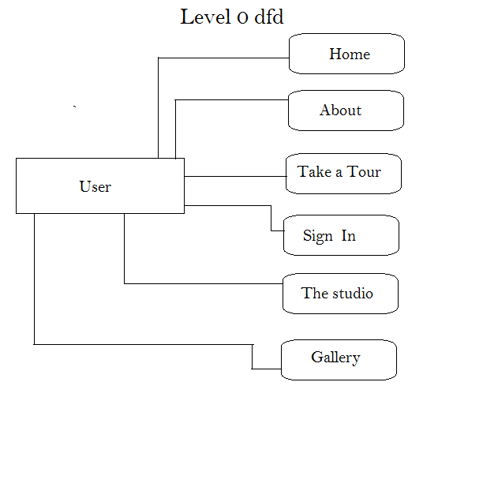

**DATA FLOW DAIGRAMS**

**LEVEL 1**

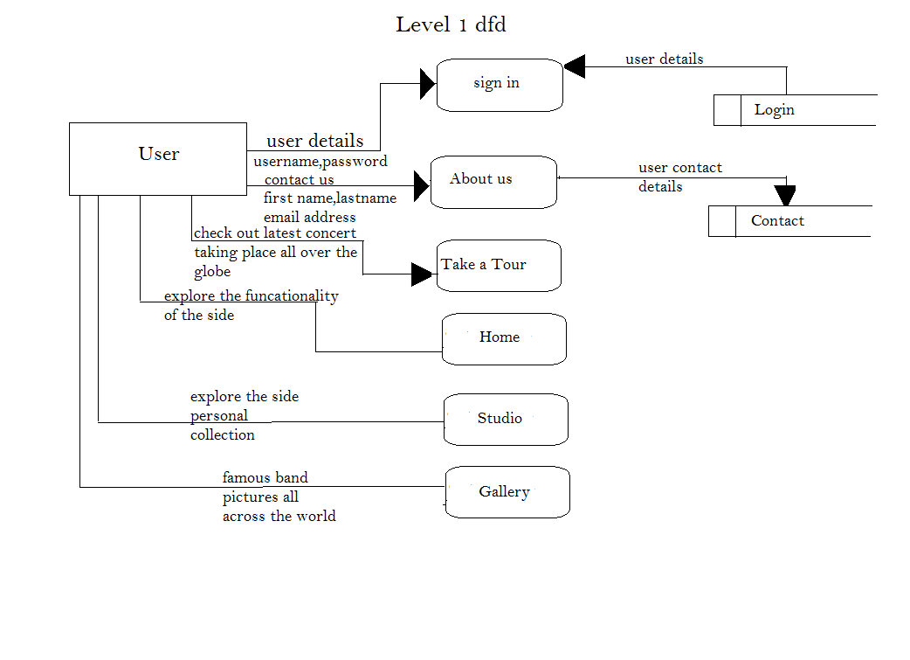

**DATA FLOW DAIGRAMS**

**LEVEL 2**

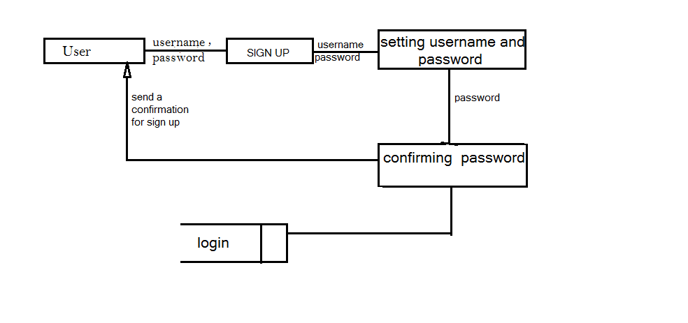

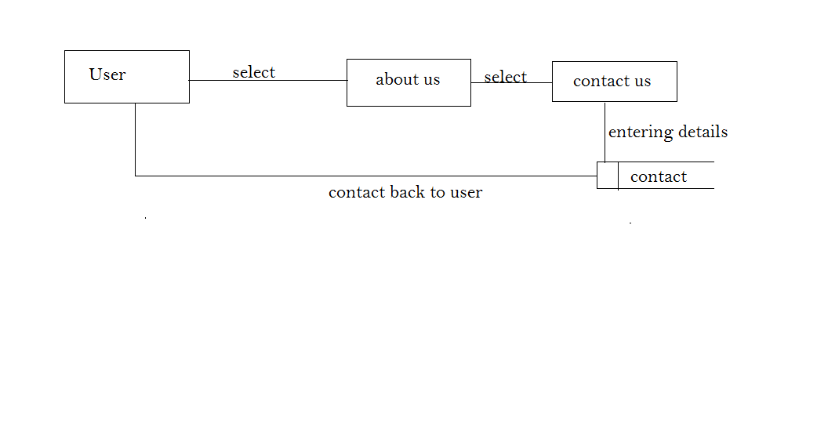

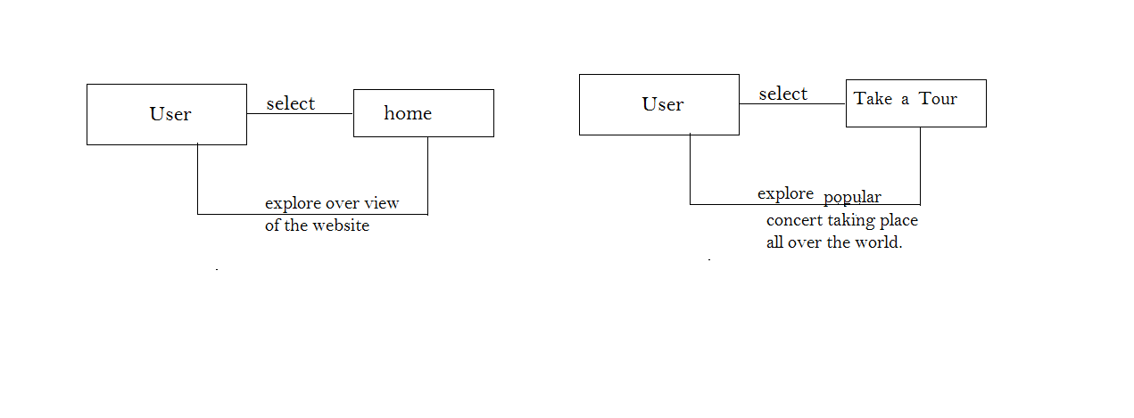

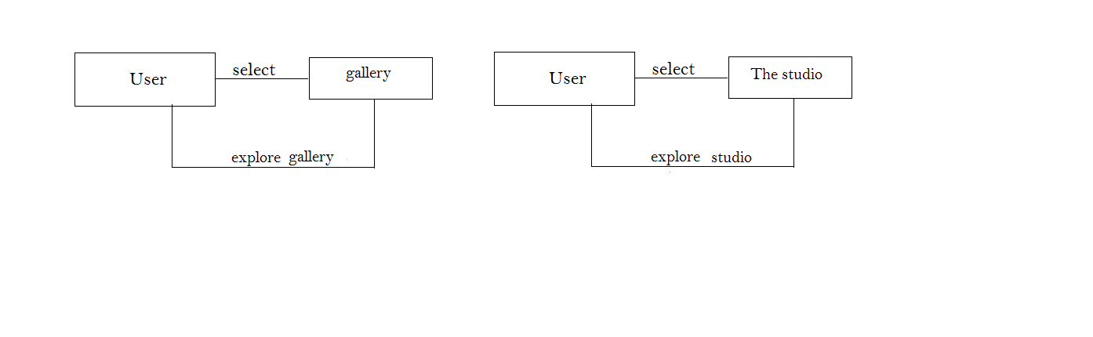

**UML DAIGRAMS**

**DEPLOYMENT DAIGRAM**

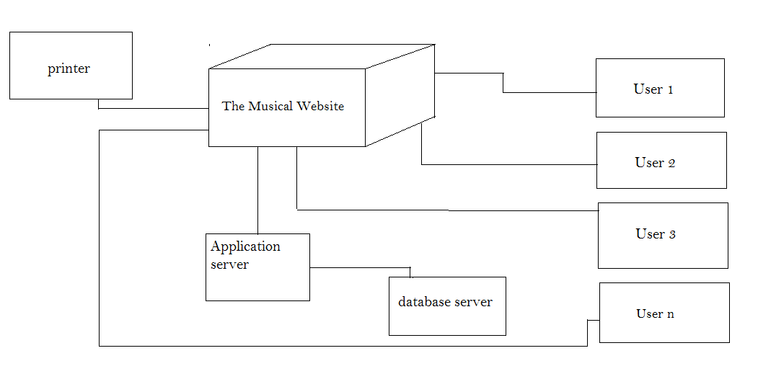

**UML DAIGRAMS**

**CLASS DAIGRAM**

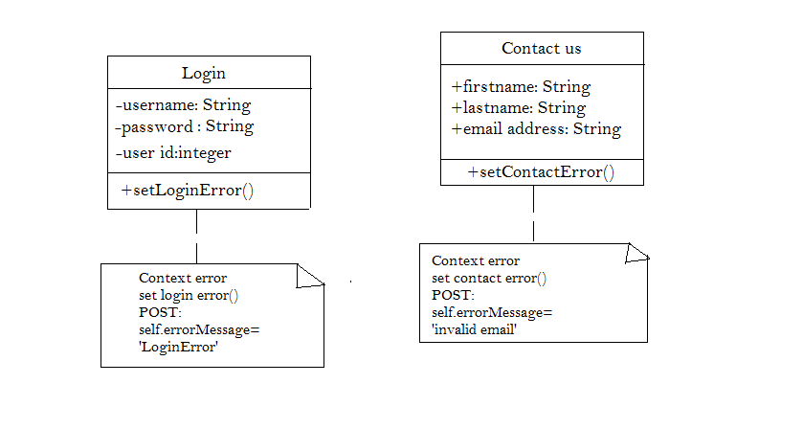

**UML DAIGRAMS**

**SEQUENCE DAIGRAM**

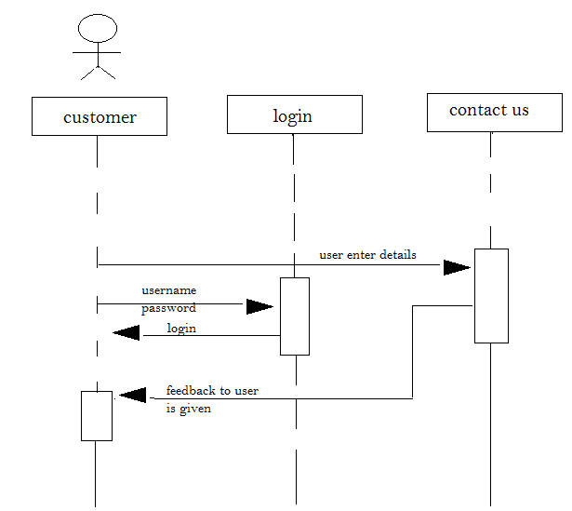

**USER INTERFACE DESIGN**

**SNAPSHOTS**

**DATABASE DESIGN**

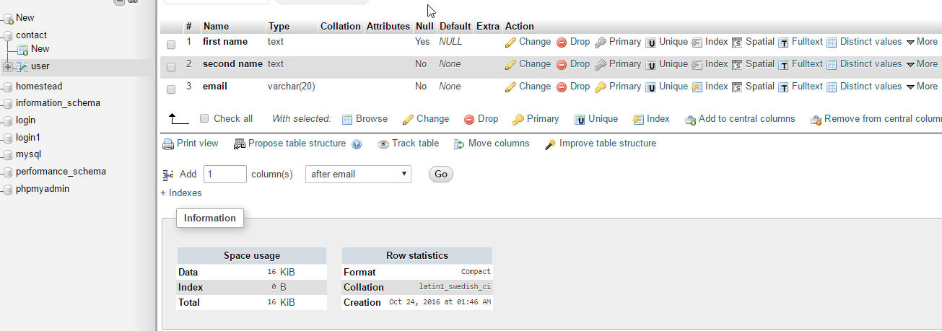

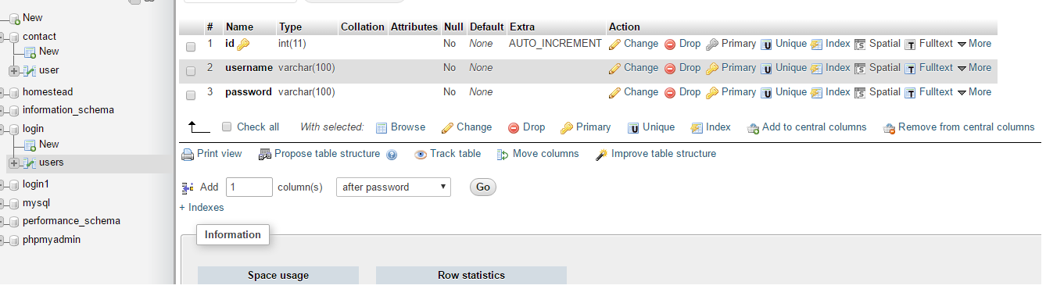

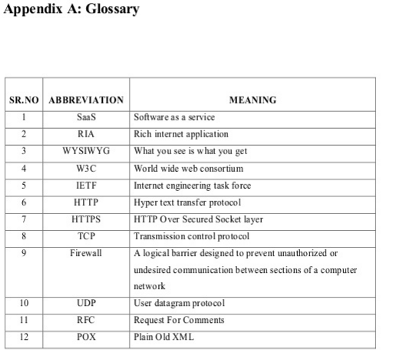

**APPENDIX B**

* **Bootstrap**

Bootstrap is a free front-end framework for faster and easier web development; Bootstrap includes HTML and CSS based design templates for typography, forms .

* **Javascript**

Programming languages are ways to communicate to computers and tell them what to do. There are many different programming languages just like there are many different lingual languages (English, Spanish, French, Chinese, etc). One is not better than the other. Developers typically are just proficient at a couple so they promote those more than others. Below are just some of the languages and links to their homepages

* **Html**

[HTML](https://developer.mozilla.org/en-US/docs/Web/HTML) is a markup language. It provides structure of a website so that web browsers know what to show.

* **Css**

[CSS](https://developer.mozilla.org/en-US/docs/Web/CSS) is a Cascading Style Sheet. CSS let’s web designers change colors, fonts, animations, and transitions on the web. They make the web look good.